1. Create user with name Techie and provide sudo access to user.
Used to create a new user account and grant administrative (sudo) privileges to perform system management tasks.
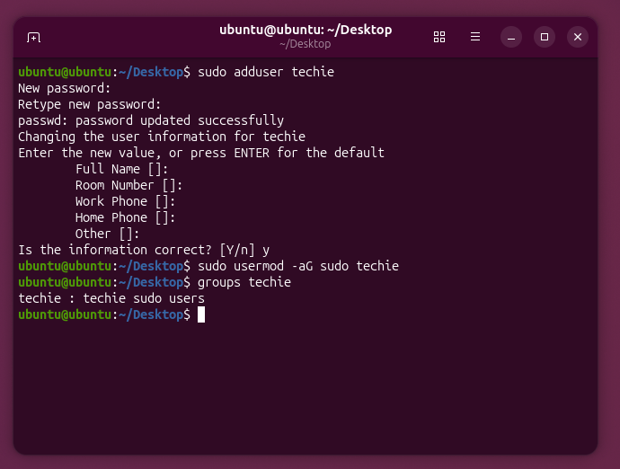
2. Navigate to the home directory.
Used to move to the user's home directory where personal files and folders are stored.
3. Create a new directory.
Used to create a new folder for organizing files and directories.
4. List the contents of a directory.
Used to display all files and subdirectories inside a directory.
5. Change the current directory.
Used to move from one directory to another in the Linux file system.

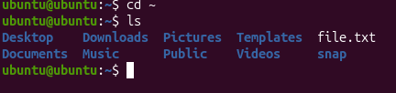
6. Create a new empty file.
Used to create a blank file before adding any content.
7. View the contents of a file.
Used to display the contents of a text file without editing it.
8. Copy a file to another location.
Used to duplicate a file while keeping the original unchanged.
9. Move a file to another location.
Used to transfer a file from one directory to another or rename it.
10. Rename a file.
Used to change the name of an existing file.
11. Delete a file.
Used to permanently remove a file from the system.
12. Grant or revoke permissions on a file or directory.
Used to control who can read, write, or execute files and directories.

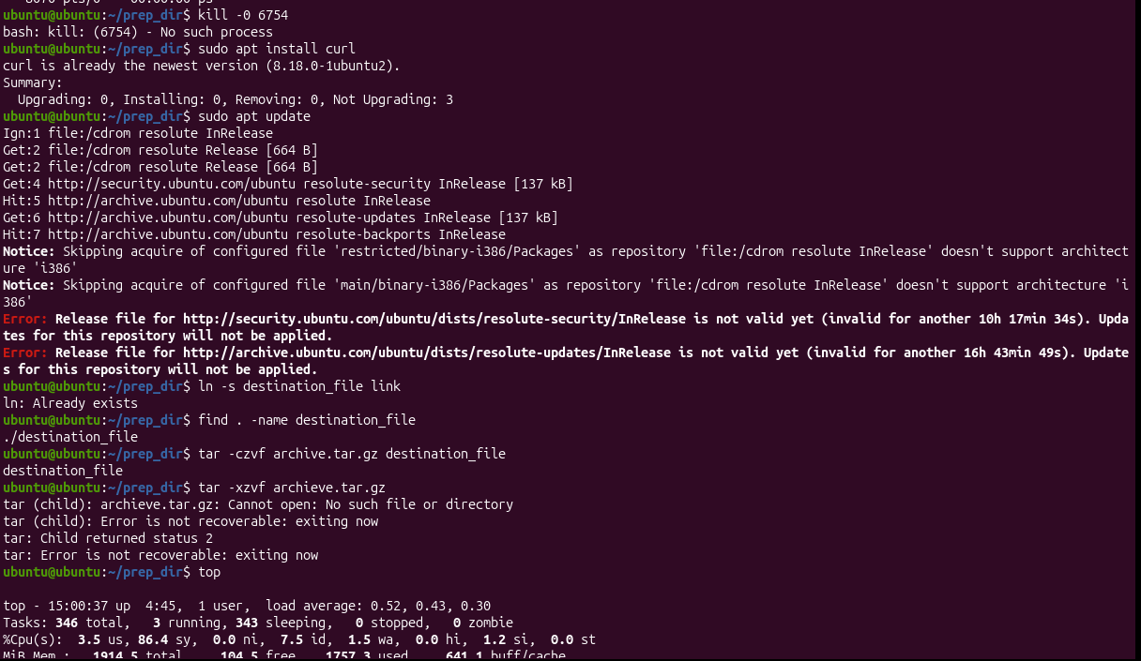
13. View the current date and time.
Used to display the system's current date and time.
14. Check the system uptime.
Used to check how long the system has been running since the last reboot.
15. View the running processes.
Used to display all currently running processes on the system.
16. Kill a running process.
Used to terminate or stop a running process using its Process ID (PID).
17. Install a package using the package manager.
Used to download and install software packages on Linux.
18. Update the system packages.
Used to update installed software packages to their latest versions.
19. Create a symbolic link.
Used to create a shortcut that points to another file or directory.
20. Search for files using the find command.
Used to locate files and directories based on name, type, size, or other conditions.

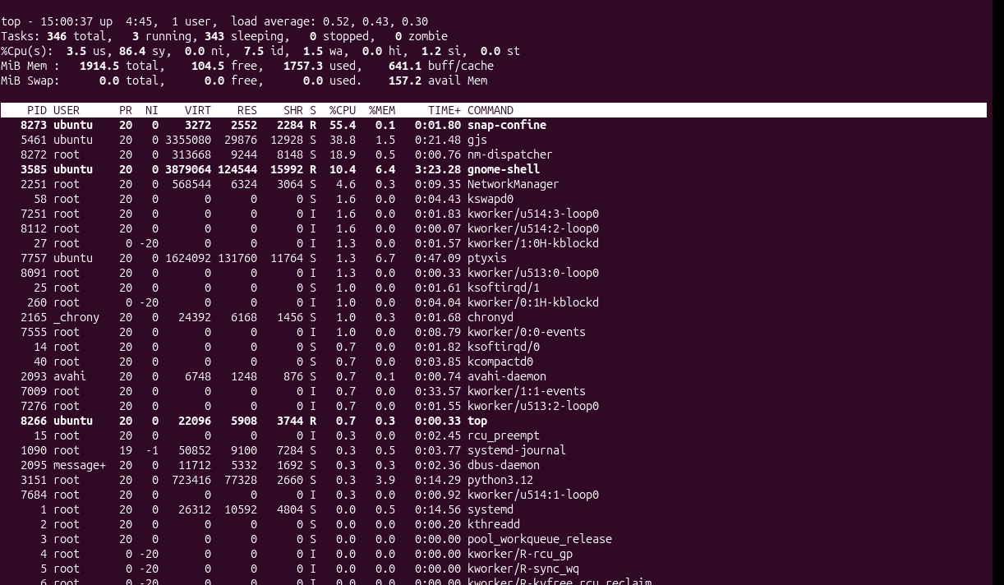
21. Compress and decompress files using tar.
Used to archive multiple files into one file and extract them when needed.
22. Monitor system resources with top or htop.
Used to monitor CPU, memory, processes, and overall system performance in real time.
23. Create and manage user groups.
Used to organize users into groups for easier permission management.
24. Set up SSH passwordless authentication.
Used to allow secure login between systems without entering a password by using SSH keys.
25. Monitor log files using tail or grep.
Used to monitor log files in real time and search for specific messages or errors.
26. Set up a web server (Apache or Nginx).
Used to host websites and web applications on a Linux server.
27. Configure and secure a MySQL Database.
Used to install, configure, and secure a MySQL database for storing application data.
28. Set up an Application Server (Apache Tomcat).
Used to deploy and run Java-based web applications.
29. Create a service file for Apache Tomcat.
Used to manage the Tomcat server as a system service using the systemctl command.
30. Print specific columns from a delimited file.
Used to extract selected columns from CSV or text files.
31. Filter and print lines based on a specific pattern or condition.
Used to display only the lines that match a specified pattern or condition.
32. Calculate and print the average, sum, or other statistics of a column.
Used to perform calculations such as sum, average, minimum, and maximum on numerical data.
33. Perform string manipulation.
Used to extract, modify, or convert text such as changing uppercase to lowercase.
34. Count the occurrences of a specific pattern in a file.
Used to count how many times a word or pattern appears in a file.
35. Sort lines based on a specific field or column.
Used to arrange data in ascending or descending order based on a selected column.
36. Merge multiple files based on a common field or column.
Used to combine related data from multiple files using a common key.
37. Substitute text in a file using search and replace.
Used to automatically replace specific words or text patterns in a file.
38. Delete specific lines based on a pattern or line number.
Used to remove unwanted lines from a file.
39. Append or insert text before or after a specific pattern or line.
Used to add new text at a specific location in a file.
40. Print only specific lines from a file.
Used to display only selected lines from a file.
41. Copy file from Linux to Windows machine.
Used to transfer files from a Linux system to a Windows computer using tools like SCP, SFTP, or WinSCP.
42. 5 Use Cases for AWK.
- Extract specific columns from CSV or log files.
- Calculate sum, average, and other statistics.
- Filter records based on conditions.
- Generate formatted reports.
- Analyze log files efficiently.
43. 5 Use Cases for sed.
- Search and replace text in files.
- Delete specific lines from a file.
- Insert or append text at specific locations.
- Modify configuration files automatically.
- Clean and format text files.

